Developing an accurate unemployment rate forecasting model is of paramount importance in addressing the challenges posed by dynamic labor markets and facilitating informed decision-making for individuals, businesses, and policymakers. Numerous studies and research efforts have contributed to this field, aiming to enhance our understanding of unemployment rate dynamics. In this related work section, we will explore some key contributions in the area of unemployment rate forecasting. The forecasting of the U.S. unemployment rate is a critical and perennial challenge in the field of economics, with far-reaching implications for policy formulation, financial markets, and societal well-being. Over the years, extensive research has been conducted to develop effective models and methodologies for predicting this crucial economic indicator. A review of the literature reveals a rich landscape of studies that employ a diverse range of econometric techniques, time series models, and data sources. This section provides an overview of key developments in the field, highlighting seminal works, recent advancements, and the predominant themes in U.S. unemployment rate forecasting. It aims to underscore the importance of accurate unemployment rate forecasts and lay the foundation for the methodology employed in this research.

Conventional forecasting models, while valuable in elucidating historical trends and patterns, often grapple with accommodating the myriad of factors influencing contemporary unemployment rates. Current forecasting models frequently encounter difficulties when trying to capture the intricate dynamics of unemployment rates. These limitations substantially impede their capacity to effectively predict shifts in labor markets. In today's swiftly evolving economic terrain, characterized by globalization, technological progress, the rapid evolution of job markets, changing skill requirements, demographic transitions, and external shocks, such as financial crises, public health emergencies and pandemics render the development of models that can deliver dependable and up-to-the-minute forecasts a challenging endeavor. Unemployment rates are marked by intricate and multifaceted dynamics.

This research project aspires to confront these hurdles by conceiving an advanced forecasting model for unemployment rates. It recognizes that the intricacies of today's labor markets demand a more all-encompassing and adaptable approach to forecasting. The primary strategy in this undertaking revolves around the amalgamation of historical labor market data with a diverse array of pertinent economic, demographic, and social indicators. Through this approach, the research seeks to create a forecasting model capable of furnishing forecasts that are not only more precise but also timelier.

Here are some key aspects of this research approach:

1. Data Integration: This research emphasizes the integration of various data sources, including historical labor market data, economic indicators (such as GDP growth, inflation rates, and industrial production), demographic information (age distribution, education levels), and social indicators (public sentiment, job search behavior). By amalgamating these data sources, the model aims to capture a more holistic view of the labor market.
2. Adaptability: The research acknowledges that labor markets are not static and are subject to rapid changes. The model developed in this study will be designed to adapt to evolving labor market conditions, ensuring that forecasts remain relevant and reliable in dynamic environments.
3. Timeliness: With the inclusion of real-time and high-frequency data, this research aims to provide timely forecasts. Timely information is crucial for businesses, policymakers, and job seekers to respond effectively to labor market changes.
4. Policy and Business Decision Support: The primary beneficiaries of this research are policymakers, businesses, and individuals. By offering more accurate and actionable forecasts, the model will enable policymakers to design targeted interventions, businesses to make informed hiring and expansion decisions, and individuals to plan their careers and job searches effectively.

In the quest for the noble objective of refining the precision of unemployment rate forecasting, this scholarly research endeavor meticulously delineates a systematic method to attain this lofty aim. More precisely, the study is dedicated to the creation of two distinct models for forecasting unemployment rates. These models undertake an exhaustive consideration of a plethora of determinants that exert influence over the labor market. The evaluation phase of this study involves the rigorous assessment of the predictive capabilities of both the SARIMAX and LSTM models. To accomplish this, the research employs a dedicated test set, which serves as the litmus test for the models' forecasting prowess. In the ensuing discourse, we shall expound upon the intricacies of this research approach:

1. Comprehensive Factor Consideration:

The first key aspect of this research is the recognition of the multitude of factors that influence unemployment rates. These factors go beyond historical trends and involve a wide range of economic, demographic, and social indicators. By considering a comprehensive set of variables, the research aims to build models that are better equipped to capture the intricate dynamics of the job market.

1. LSTM Model:

The utilization of LSTM, a type of recurrent neural network, represents a departure from traditional time series forecasting methods. LSTM is well-suited to modeling sequences of data and has demonstrated significant promise in capturing long-term dependencies in time series data. In this research, the LSTM model will be employed to analyze and forecast unemployment rates. LSTM's ability to learn from historical data and adapt to changing patterns makes it particularly valuable in the context of dynamic labor markets.

1. ARIMA Model:

ARIMA, on the other hand, is a well-established time series forecasting method. Its strength lies in its ability to model and forecast time series data by considering autoregressive, differencing, and moving average components. The ARIMA model, which has been widely used in economics and finance, provides a reliable benchmark against which the LSTM model's performance can be compared.

1. Methodological Comparison:

A crucial aspect of this research is the side-by-side comparison of the LSTM and ARIMA models. This comparison will allow for an assessment of the effectiveness and performance of each approach in forecasting unemployment rates. The aim is to identify the strengths and weaknesses of both models and potentially leverage the best features of each to create a more robust forecasting tool.

1. Model Adaptability:

The adaptability of the developed models is of paramount importance. Given the ever-evolving nature of job markets, the research emphasizes the need for models that can adjust to changing conditions. LSTM's adaptability to shifting data patterns and SARIMA's ability to model different components of time series data will be closely examined in this context.

1. Practical Implications:

The ultimate goal of this research is to provide practical, actionable insights for policymakers, businesses, and individuals. A more accurate unemployment rate forecasting model can empower these stakeholders to make informed decisions in a timely manner, navigate labor market fluctuations, and implement effective strategies.

1. Performance Metrics Utilization:

The assessment is not limited to mere visual comparisons; rather, it employs quantitative performance metrics to furnish a comprehensive understanding of each model's accuracy. Key metrics, such as the Mean Absolute Error (MAE) and Root Mean Squared Error (RMSE), are computed to gauge the disparities between the model's forecasts and the observed values. These metrics serve as a basis for numerical evaluation, enabling a precise assessment of the predictive strengths and weaknesses of each model. The adoption of these performance metrics, beyond MAE and RMSE, allows for a more comprehensive evaluation of the models. Additional metrics may include Mean Absolute Percentage Error (MAPE), which provides insights into the relative accuracy of forecasts, or R-squared (R²), which assesses the model's ability to explain the variance in the observed data.

By systematically comparing model forecasts with real data and applying quantitative metrics, this research ensures a robust and objective evaluation of the SARIMAX and LSTM models, ultimately yielding valuable insights into their forecasting accuracy and reliability. These findings will be instrumental in guiding decision-makers and stakeholders in leveraging the most effective model for making informed decisions in the dynamic realm of unemployment rate forecasting.

The United States' national unemployment rate (UR), which has been seasonally adjusted, is disseminated on a monthly basis by the Bureau of Labor Statistics (BLS), accessible through their website at www.bls.gov. The existing seasonal adjustment approach employed by the BLS is denoted as "X-13 ARIMA," and more comprehensive insights into this method can be gleaned at <https://www.bls.gov/cps/seasonal-adjustment-methodology.htm>.

The UR index for the month denoted as 't' specifically pertains to individuals who find themselves without employment but remain available for work during the week inclusive of the 12th day of month 't'. Additionally, these individuals have actively sought job opportunities in the preceding four weeks, which culminate with the reference week.

This vital statistical information, at the federal level, spans from January 1948 and extends up to the most recent data. It is conveniently obtainable for download via <https://fred.stlouisfed.org/series/CPILFESL>.

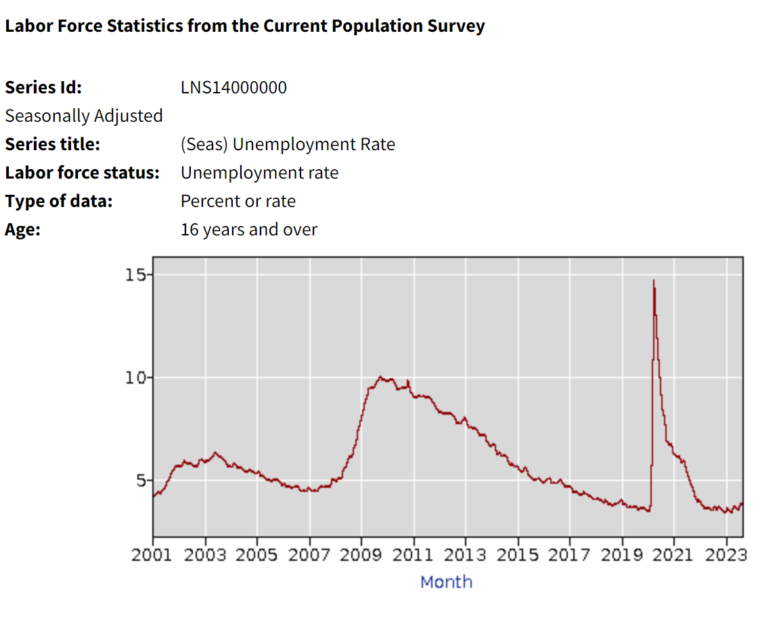

In Figure, it is evident that the data representing the unemployment rate (UR) exhibits a pronounced asymmetry in its cyclical patterns, especially during the periods of severe economic downturns, which predominantly shape the temporal evolution of the UR data. We observe that rapid, steep ascents culminating in sharp peaks typify the nature of general economic contractions, while the UR data feature prolonged and gradual descents, characteristic of business expansions.

The endeavor of forecasting the unemployment rate in the United States necessitates the application of statistical models to anticipate forthcoming values, drawing insights from a rich tapestry of historical data. In assessing the precision of these predictions, we employ a set of widely recognized metrics, which encompass the Mean Absolute Error (MAE), Mean Squared Error (MSE), and the Mean Absolute Percentage Error (MAPE).

To evaluate the precision of our forecasts, we employ the following quantitative measures:

1. Mean Absolute Error (MAE): MAE quantifies the average absolute disparity between the projected values and the real values. It serves as a yardstick for the model's predictive accuracy.

2. Mean Squared Error (MSE): MSE determines the average of the squared deviations between the projected and actual values, offering greater emphasis on larger discrepancies.

3. Mean Absolute Percentage Error (MAPE): MAPE evaluates the percentage variance between the predicted and actual values, thereby revealing the relative accuracy of the forecasts.

The mathematical expressions for these metrics are elucidated as follows:

- MAE = Σ (|actual - predicted|) / n

- MSE = Σ (actual - predicted) ^2 / n

- MAPE = (Σ (|actual - predicted| / actual) / n) \* 100

Here, "actual" pertains to the observed or historical values, "predicted" denotes the values forecasted, and "n" signifies the count of data points.

In the phase of interpretation, the outcomes of MAE, MSE, and MAPE should be scrutinized to gauge the efficacy of the model. A diminishment in MAE and MSE signifies heightened accuracy, while a decreased MAPE implies superior relative precision.

A commitment to continual enhancement is indispensable. This entails the refinement of the forecasting model, adjustments to model parameters, and the integration of fresh data as it becomes available. These measures serve to improve the precision of forthcoming forecasts.

In summation, the delineated framework provides a top-tier perspective on the process of forecasting the unemployment rate in the United States and the concurrent assessment through MAE, MSE, and MAPE. The selection of the forecasting model and the intricacy of the analysis shall be contingent upon the specifics of the dataset, the temporal scope, and the requisite degree of sophistication.